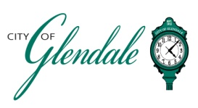
NOTICE OF PUBLIC MEETING
JUNE 2, 2025 – 6:15 P.M.
BOARD OF ALDERMEN WORKSHOP

- MEETING CALLED TO ORDER
- ROLL CALL
- NEWLY ELECTED OFFICIAL ORIENTATION
- ADJOURNMENT

_______________________
Gabrielle Macaluso
Deputy City Clerk Posted 9:00 a.m., May 30, 2025

